**San Francisco Bay University**

**CS350 - Data Structures**

**Homework Assignment #6**

**Due day: 3/31/2023**

**Instructions:**

**a. Push the source code to GitHub**

**b. Please follow the code style rule like programs on handout.**

**c. Overdue homework submission can’t be accepted.**

**d. Take academic honesty and integrity seriously (Zero Tolerance of Cheating & Plagiarism)**

1. Write a function or method with positive *int* type argument, such as ***genBin(7)****,* and outputs will be **binary** number sequence from to , like by using **queue** structure
2. Create a function to simulate **stack** push & pop operations by using only **ONE** queue
3. **Priority** **Queue** is a queue with following properties
   1. Every item has a priority associated with it.
   2. In pop operation, an element with high priority will be dequeued (deleted) before an element with low priority.
   3. If two elements have the same priority, they are served according to their order in the queue.

For example, each element in a given queue is *char* type and priority of each element is ASCII code value, write functions to complete push and pop operations

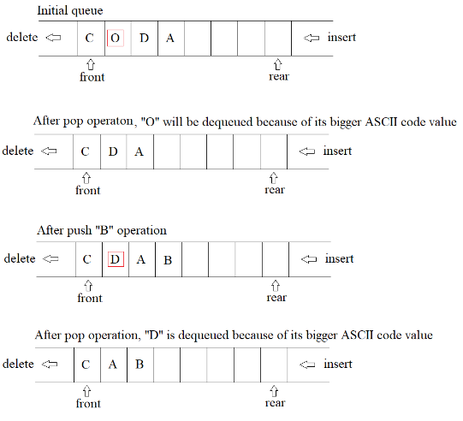

1. Given a **circular queue** with **max** *size = M* to save each element, after several times enqueue (insert) & dequeue(delete) operations, *front & rear* have their own values, write a function or method ***getNumElem(size, front, rear)*** to find how many elements are in the **circular queue**